In switching ON/OFF for lamps different components are involved:
- ICS (logics)
- DIGIO board (ON/OFF)
- Additional electronics (e.g. to trigger power supply or to switch the right lamp on)
- ESTERS station (current measurements)
- Power supply “Tölner”

Tölner provides power for the lamps. When triggered the current increases until the final value is reached. The duration of the ramp is about 30 seconds. When triggered the next time the power ramp goes down. During tests in Europe we found from time to time synchronisation problems between software and Tölner. We have improved the electronics and the occurance of the asynchronism became very rare. How get rid of this assynchronism is described in the Operations and Maintenance Plan”. The simplest is to reset Tölner (OFF + Start) but currently, because of the large number of failures, this is not efficient (see below).

During tests on Paranal the frequency of these failures became very high e.g. from 24 ON/OFF operations 2 have been failed. The analysis of failures shows that sometimes software and sometimes Tölner is in a wrong state. The detailed analysis and hopefully solving of the problem will be made during Commissioning 2.

The system is currently in the normal state i.e. the lamps can be switched ON/OFF by software.

Below you will find a description allowing to switch ON/OFF the lamp using hardware only as a backup solution for work with the lamps until Commissioning 2. Following information is important when working in this mode:
- The stability of lamps is reached after about 4 minutes i.e. wait this time before starting first exposure
- Do not forget to switch off the lamp after all flats are acquired e.g. when you will close the mirror covers

Activities necessary for change from software to hardware operation:
  - Open cabinet on the front side
  - Switch Tölner OFF
  - Open cabinet on the rare side
  - Disconnect cable FF-Lamp1 ... or FF-Lamp2 ... going to lamps (photo)
  - Disconnect the red and blue cable from Tölner (uppermost slot / photo)
  - Connect exit of Tölner with cable going to lamps using auxiliary cable (photo)
  - Change programing of Tölner (from software to hardware control)
    - Switch Tölner ON
    - Press button STOP
    - Press simultaneously buttons SPECIAL and EXT
    - Change external control to OFF (“Etr oFF” in display), use the arrow buttons below display
    - Press button SPECIAL
Now Tölner is ready to be triggered by hand to run the ON/OFF ramps.
    - Press button START – ramp ON
    - Press button START – ramp OFF
    - ...

Activities nacessary for change from hardware to software operation:
- Open cabinet on the front side
- Switch Tölner OFF
- Open cabinet on the rare side
- Disconnect auxiliary cable from FF-Lamp1 or 2 and from exit of Tölner
- Restore the normal cabling
- Change programing of Tölner (from hardware to software control)
    - Switch ON Tölner
    - Press button STOP
    - Press simultaneously buttons SPECIAL and EXT
    - Change external control to ON (“Etr on” in display), use the arrow buttons below display
    - Press button SPECIAL
    - Press button START (“Etr” in leftmost part of display)
Now Tölner is ready to be triggered by from software

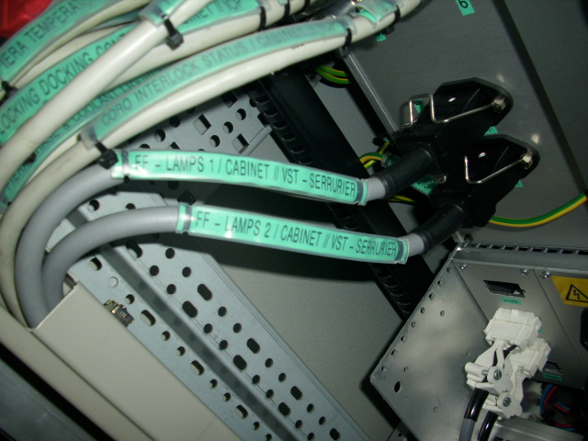
Normal connections when lamps are controlled by software (power cables to lamps).

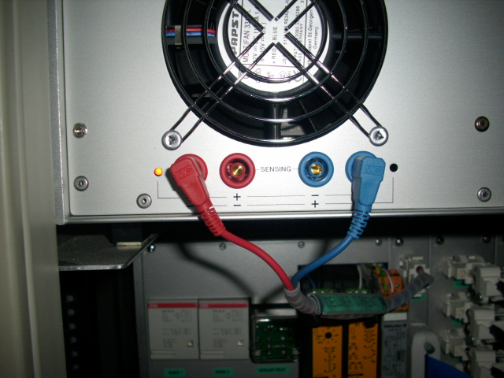
Normal connections on Tölner output (software control of lamps)

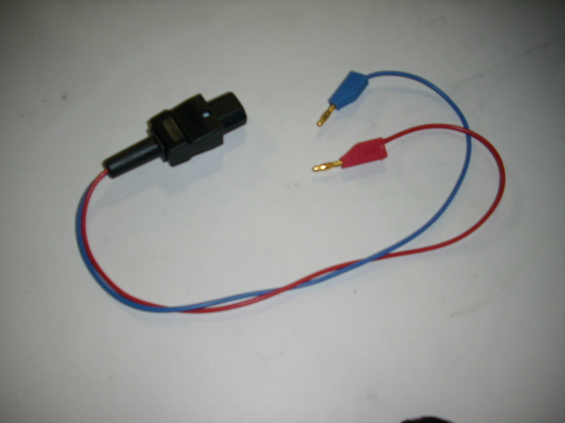
Auxiliary cable for direct connection of Tölner with lamps

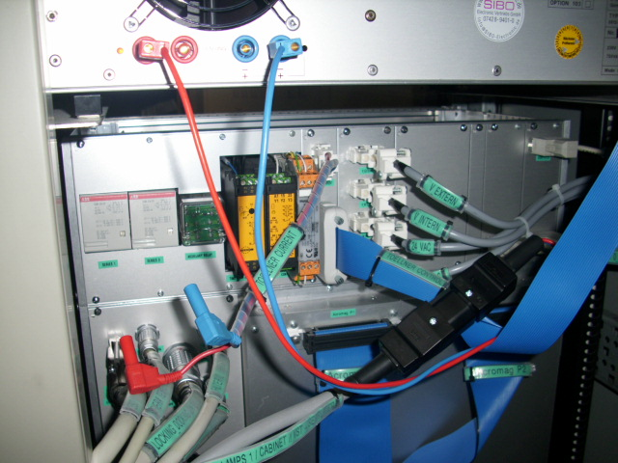
Lamps connected directly to Töner

